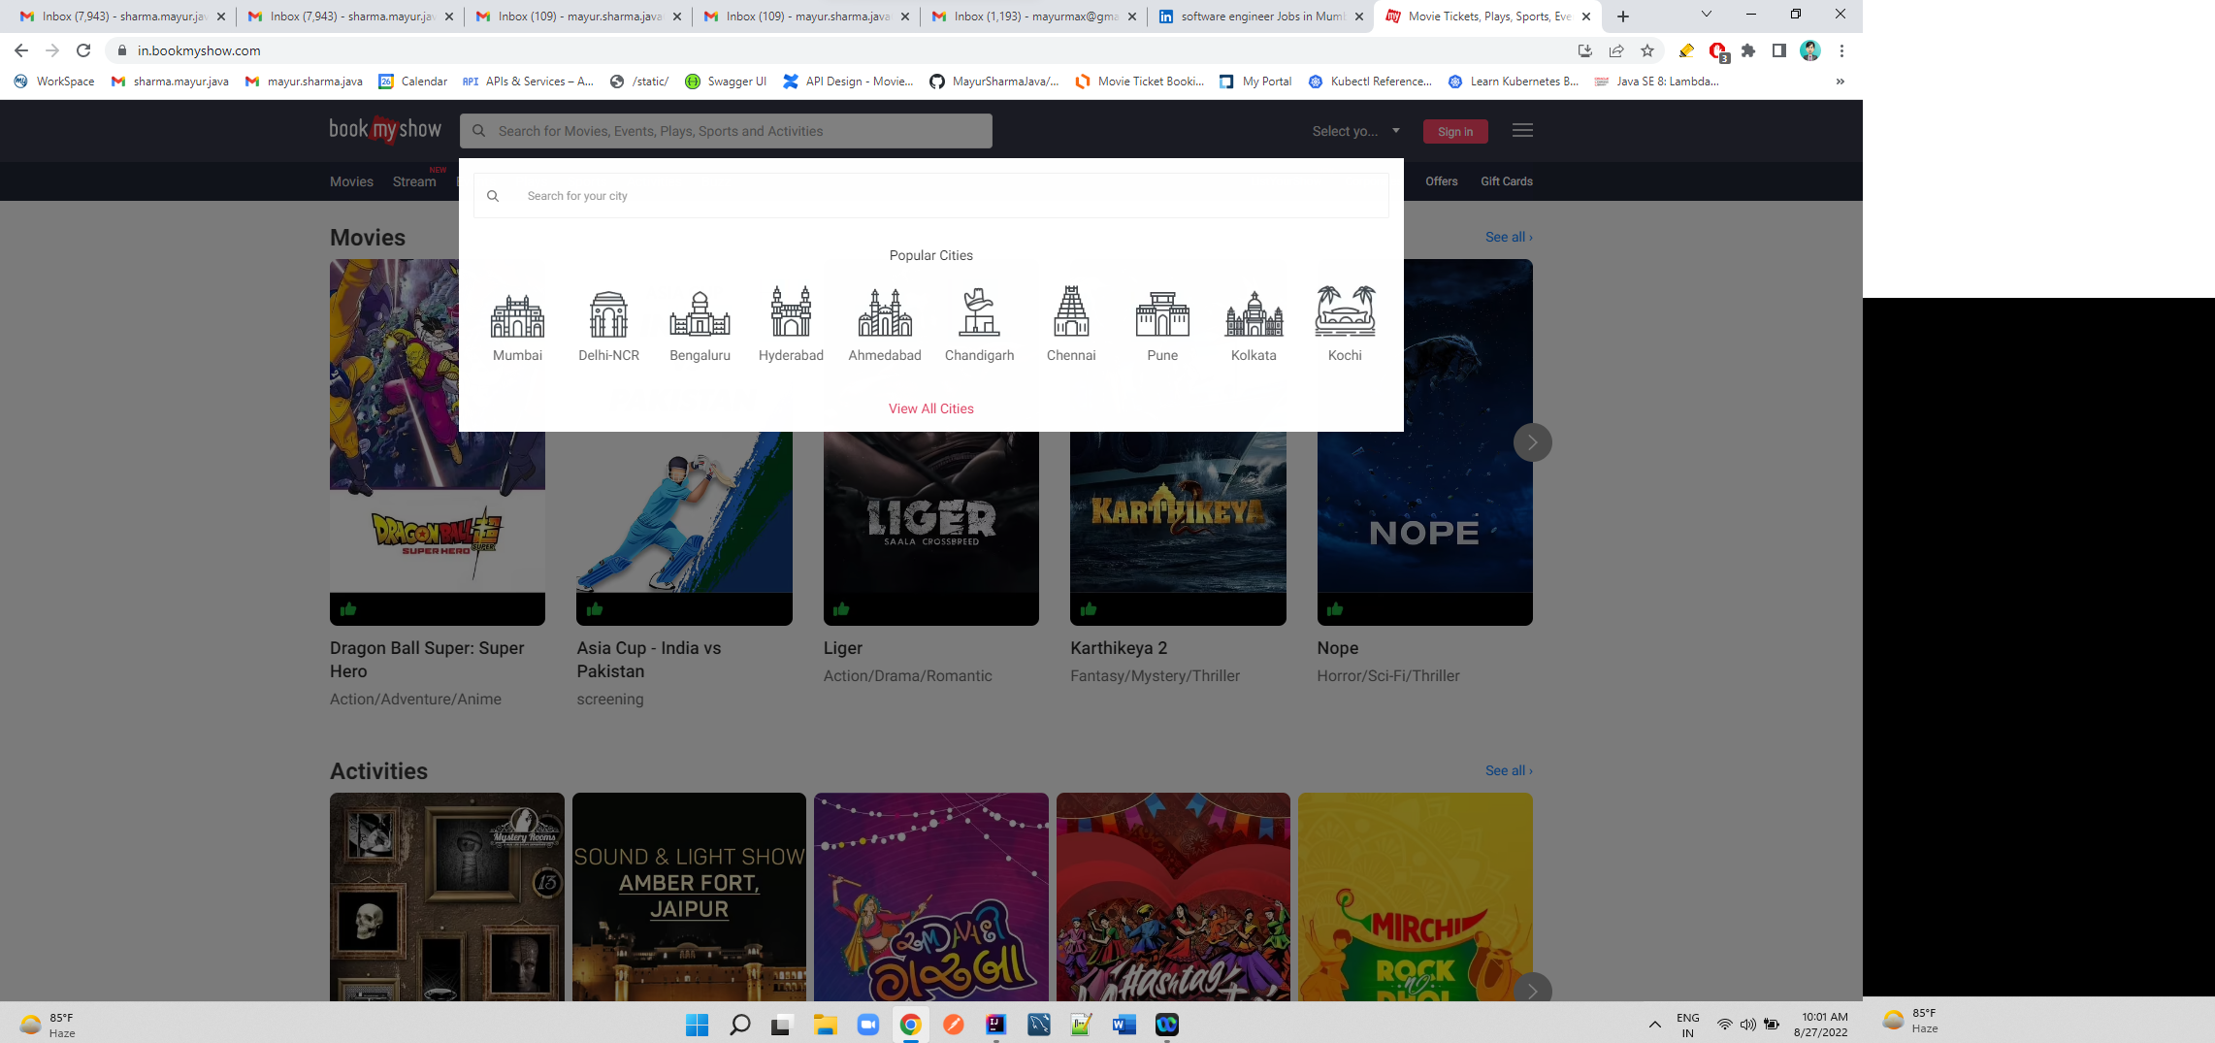

**Api/home/{city}/recommendations: return Recommended movie Object**

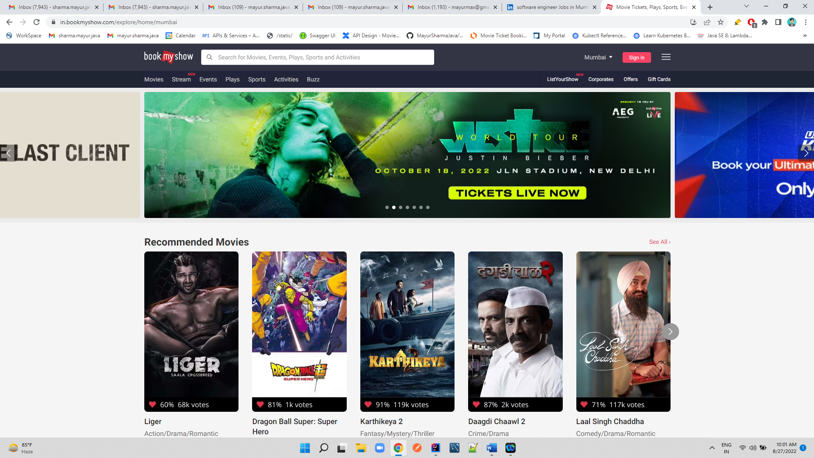

**Api/{city}/{movie} – will get Below Page**

**Selecting One movie**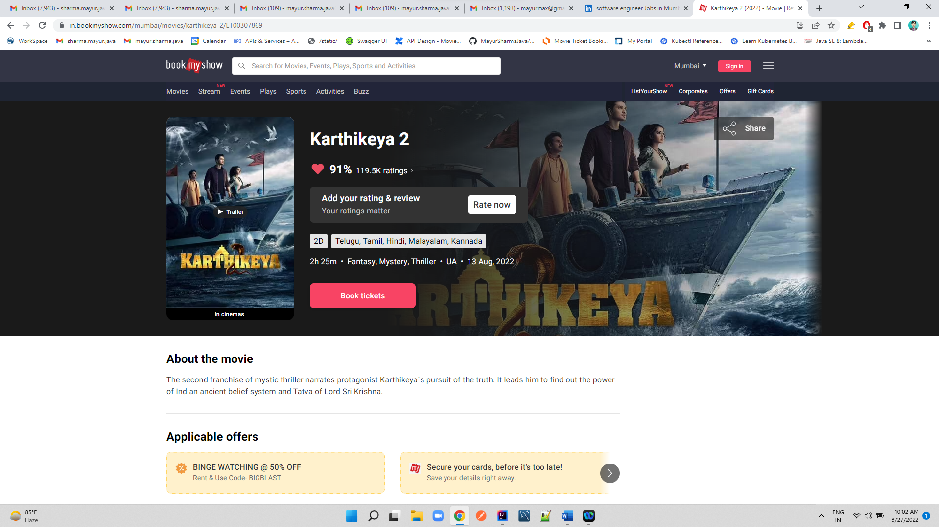

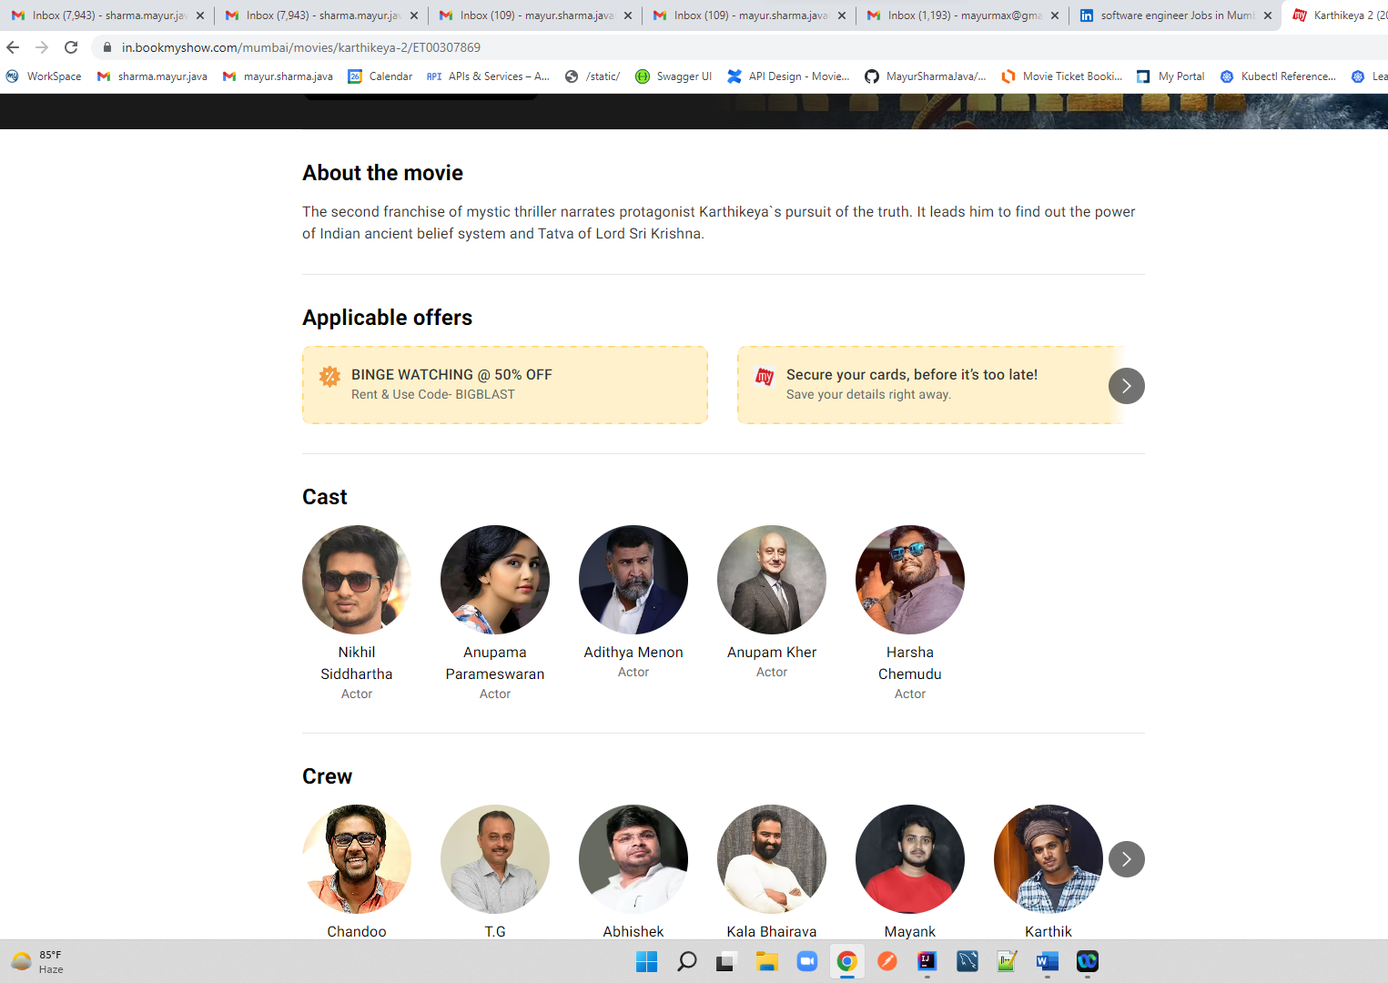

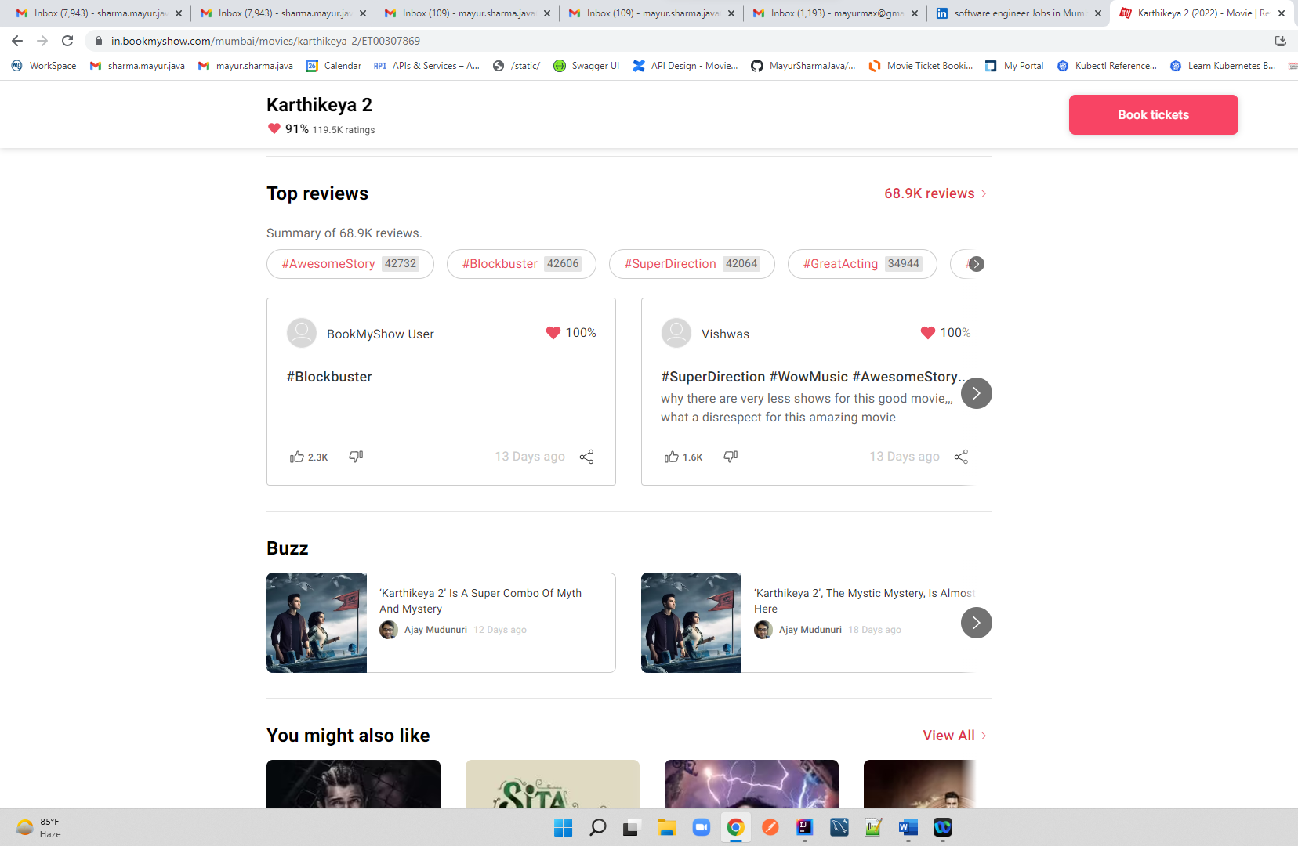

**Api/{city}/{movie}/LanguageFormat**

**When u click Book ticket**

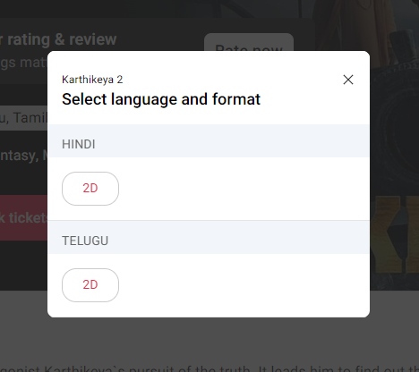

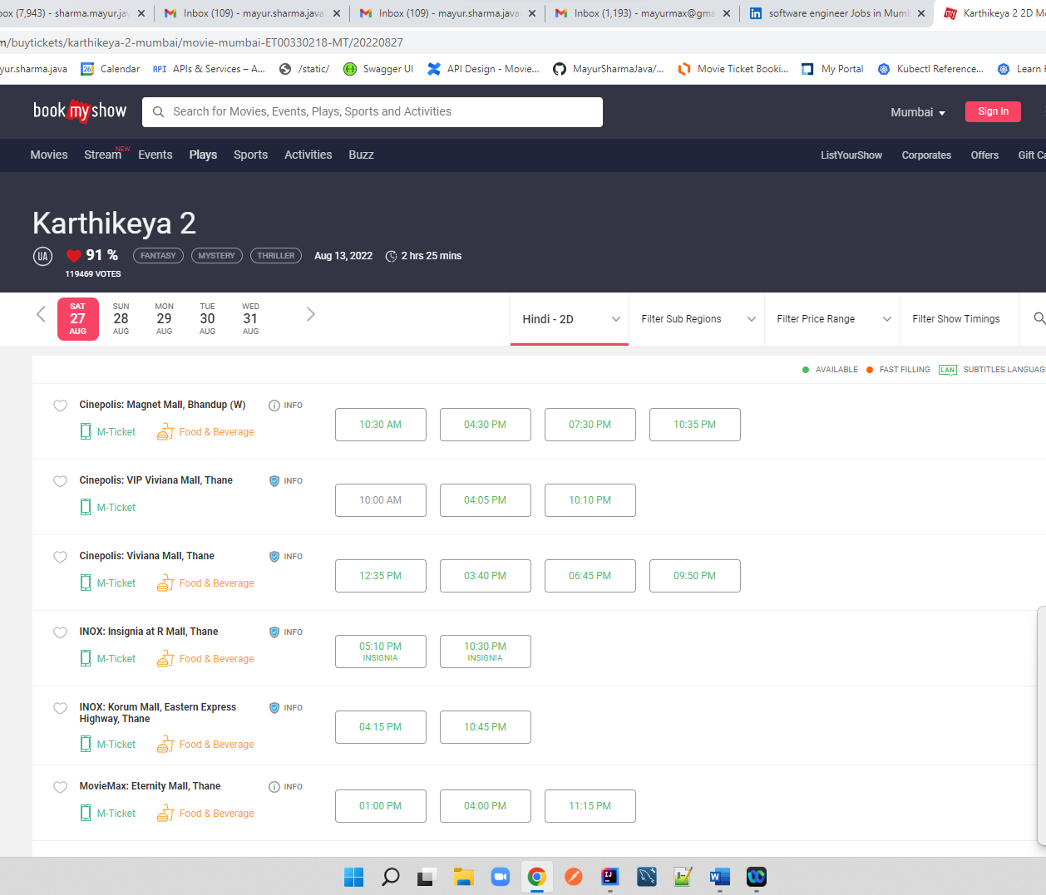

**Select One**



**Seat Map is shown for Seat selection**

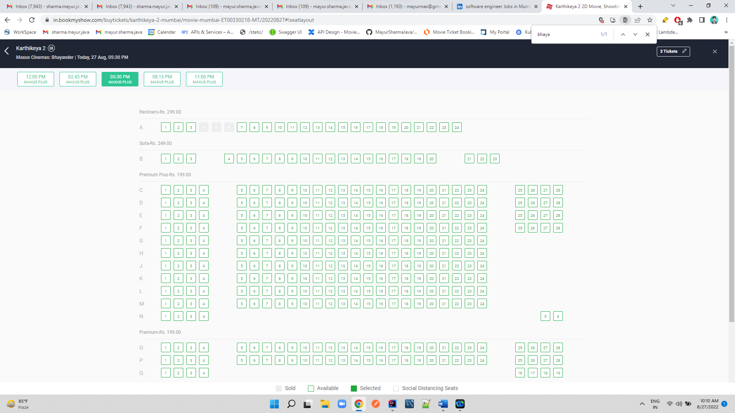

**Select Seat Total is shown**

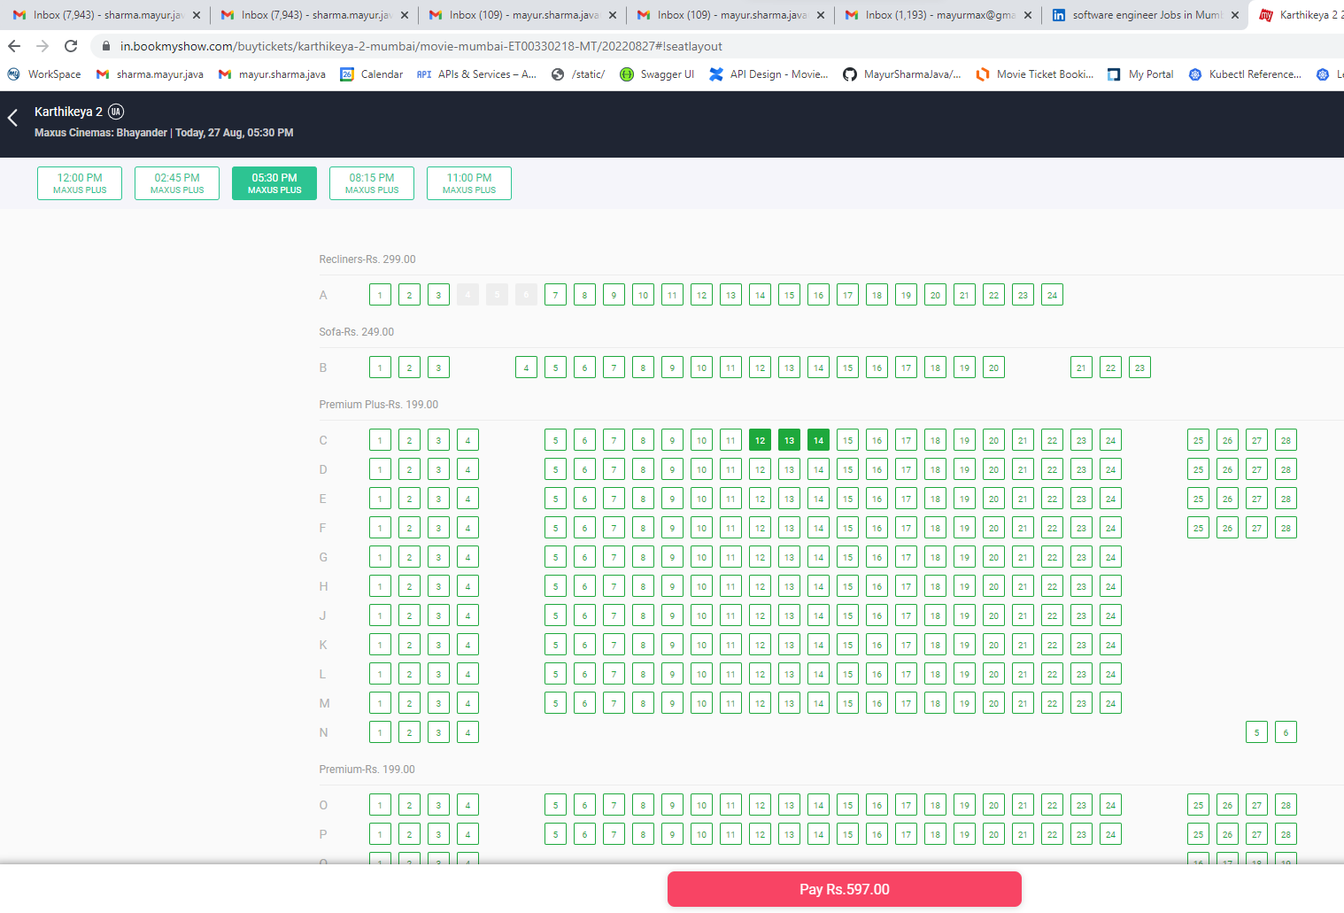

**Click On Pay –**

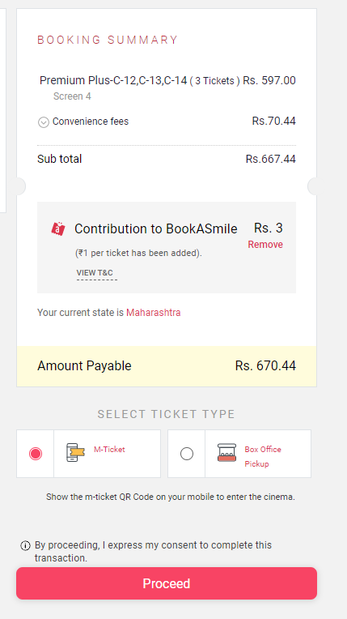

**Proceed Payment : Locked for Payment 10 min**

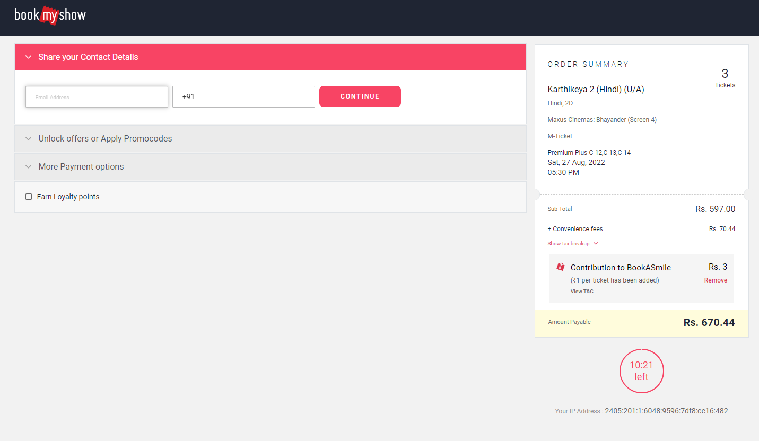

**Once the payment is Done Ticket is Sent on mobile and Email and WhatsApp**